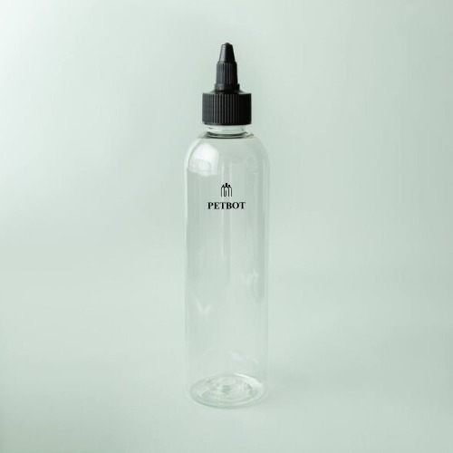

**Hair care bottle:**

**MOQ:**

For **stock** glass bottles, the MOQ is 10,000 pieces.

For **custom** requirements, please refer to the following MOQ：

* Bottles under 100ml - 100,000 pcs
* Bottles in 100~150ml - 30,000 pcs
* Bottles larger than 150ml - 50,000 pcs

CUSTOMIZATION:

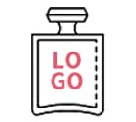

Logo

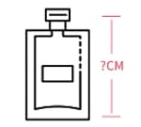

Size

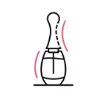

Shape

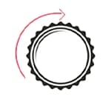

Cap